
RAMAIAH
Institute of Technology
USN | 1 | M | S

(Autonomous Institute, Affiliated to VTU)
(Approved by AICTE, New Delhi & Govt. of Karnataka) Accredited by NBA & NAAC with ‘A’ Grade

SEMESTER END EXAMINATIONS – JUNE 2019

Course & Branch | : | B.E. : Electrical and Electronics Engineering | Semester | : | VI
Subject | : | Advanced Industrial Automation | Max. Marks | : | 100
Subject Code | : | EEE26 | Duration | : | 3 Hrs

Instructions to the Candidates:
- Answer one full question from each unit.

 |  | UNIT- I
1. | a) | Discuss the different types of IEC-61131 programming standards in detail with suitable examples. | CO1 | (08)
 | b) | Explain in detail the operation of DC input module with block diagram. | CO1 | (08)
 | c) | Define Scan cycle. | CO1 | (04)
2. | a) | List any four types of logical sensors and explain their operation in detail. | CO1 | (08)
 | b) | Illustrate the functioning of analog voltage input module with neat block diagram. Provide an example of output voltage variation with the variation of the position of potentiometer knob. | CO1 | (08)
 | c) | Illustrate the advantages of using PLC in automation industries. | CO1 | (04)
 |  | UNIT- II
3. | a) | Draw the ladder Diagram for the multiplexer that will take one of four inputs bits D1, D2, D3 or D4 and make it the output X, depending upon the values of the address bits, A1 and A2.  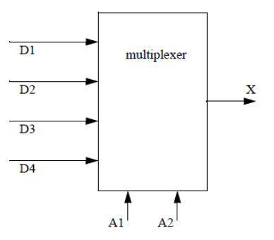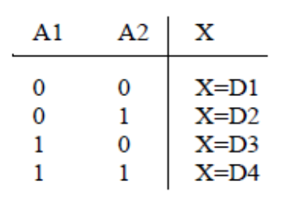 | CO3 | (06)
 | b) | Write a program to achieve the following :  A motor will be controlled by two switches. The Go switch will start the motor and the Stop switch will stop it. If the Stop switch was used to stop the motor, the Go switch must be thrown twice to start the motor. When the motor is active a light should be turned on. The Stop switch will be wired as normally closed. | CO3 | (08)
 | c) | Explain the following instructions:  - Latch Output Coil  - Transitional Contact  - Examine ON. | CO2 | (06)
4. | a) | Convert the following ladder logic to a Boolean equation. Then simplify it, and convert it back to simpler ladder logic.  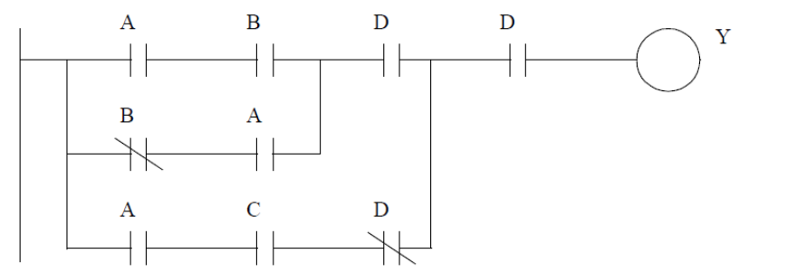 | CO3 | (07)
 | b) | Write a ladder logic program to run a conveyor by switching ON or OFF a motor. Objects are placed on the conveyor with an optical detector. When the optical detector goes ON, system should wait 5 seconds, and then stop the conveyor. After a delay of 20 seconds the conveyor will start again. Use a start and stop button - a light should be on when the system is active. | CO3 | (07)
 | c) | Explain the operation of latch and unlatch coil instruction. | CO2 | (06)
 |  | UNIT- III
5. | a) | Explain the fail safe wiring of the stop switch. | CO2 | (05)
 | b) | Explain the process of troubleshooting PLC inputs. | CO2 | (07)
 | c) | What are the benefits of system documentation? | CO2 | (05)
 | d) | Define: Wire labeling. | CO2 | (03)
6. | a) | Write a short note on special I/O connections. | CO2 | (08)
 | b) | Explain the panel enclosure of a PLC system. | CO2 | (08)
 | c) | Mention the factors responsible for selecting a PLC for particular application. | CO2 | (04)
 |  | UNIT- IV
7. | a) | Describe the concepts of the implementation of HMI. | CO4 | (07)
 | b) | Differentiate between hardware HMI and software HMI. | CO4 | (05)
 | c) | What kind of information is available in historical process data reports? Explain. | CO4 | (08)
8. | a) | Draw the trends and graphical representation for water level controller application. Provide required assumptions. | CO4 | (08)
 | b) | When and how alarms are used? | CO4 | (05)
 | c) | Draw the alarm logger and explain in detail. | CO4 | (07)
 |  | UNIT- V
9. | a) | Mention the significance of RTU. | CO5 | (06)
 | b) | What are Intelligent Electronic Devices? Briefly explain. | CO5 | (06)
 | c) | Differentiate between DCS and SCADA. | CO5 | (08)
10 | a) | Describe the function and structure of Master Terminal Unit. | CO5 | (08)
 | b) | Write short notes on the communication interfaces of modern RTU. | CO5 | (06)
 | c) | Write short note on DCS. | CO5 | (06)

****************

